Software Prototype

**Introduction**

The software prototype is developed considering the core functionality of the project. The main aim of this prototype is to show how a .zip file is uploaded from a local drive to the server and automatically unpacked.

Also how a .java file is uploaded and extracted. This software prototype also explains the basic java file being upload and executed to generate the .class file within a click of the button “EXECUTE”.

**Software and Servers Used:**

* HTML
* CSS
* BOOTSTRAP
* PHP
* XAMPP

**Prototype**

The below page shows options to upload a .zip file or .java file. The user needs to click on the choose file option to upload a file

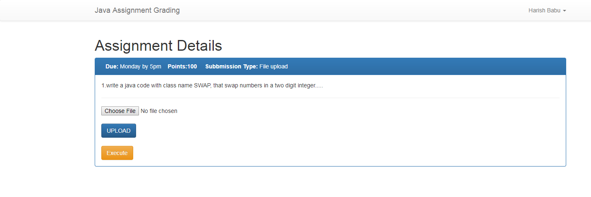

Fig: a

The below page shows that the file is being selected from the local drive.This functionality is achieved using PHP and Xampp server.

For example in this case the “oops proj.zip” file is being selected to upload

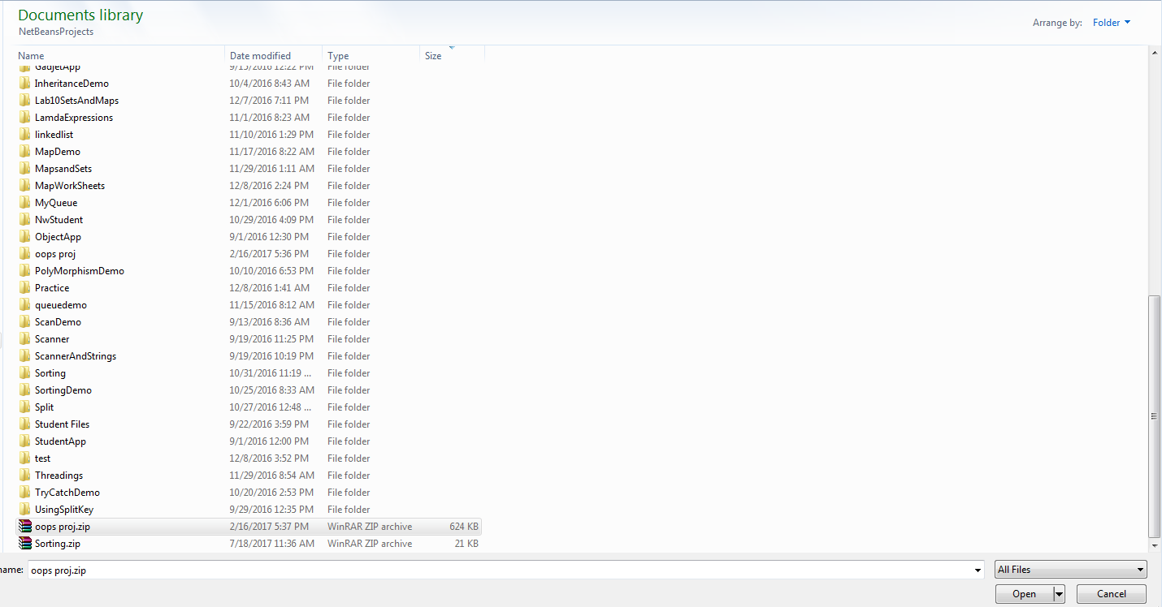

Fig: b

This page shows that the file “oops proj.zip” file is uploaded.

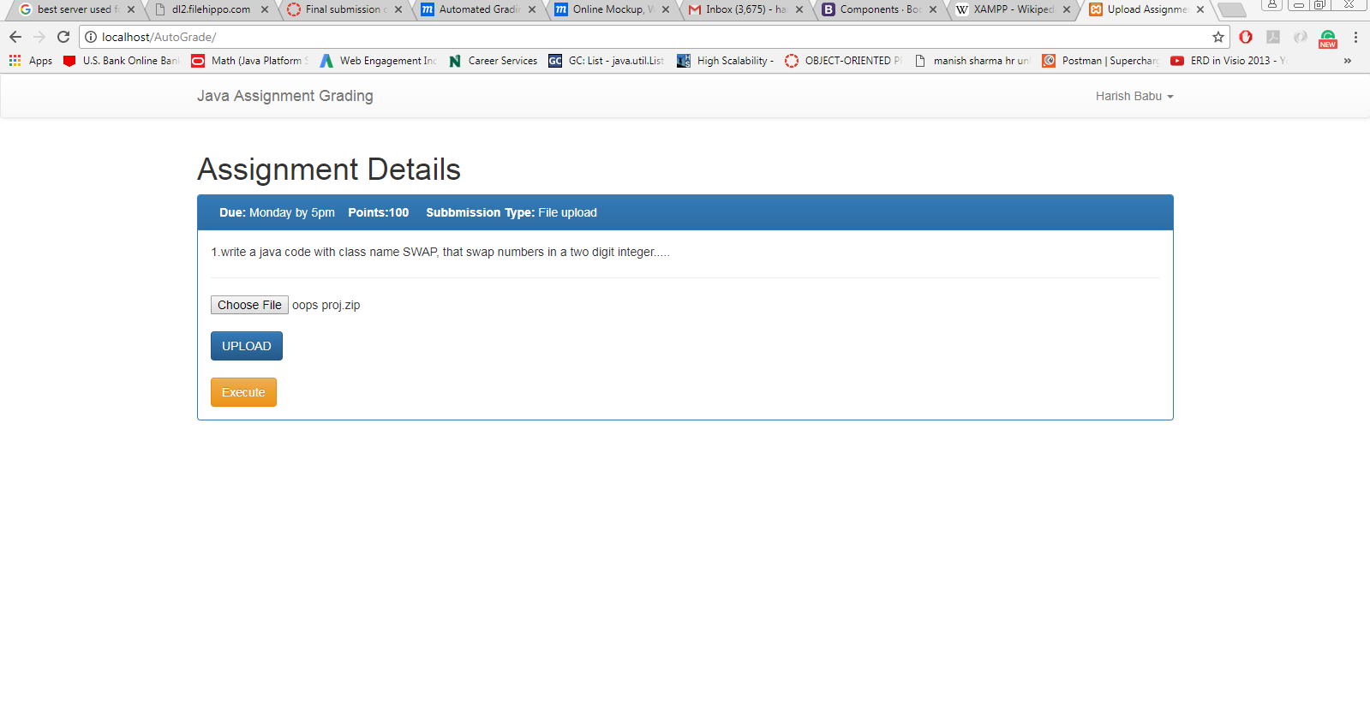

Fig: c

This page shows the message “oops proj.zip” file is uploaded and unpacked

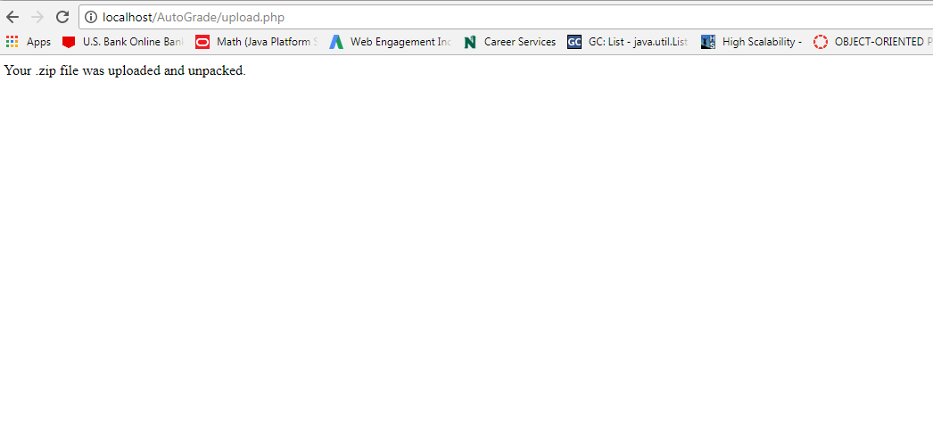

Fig: d

The below pages shows unpacked folder named “oops proj” and the contents inside the “oops proj” folder.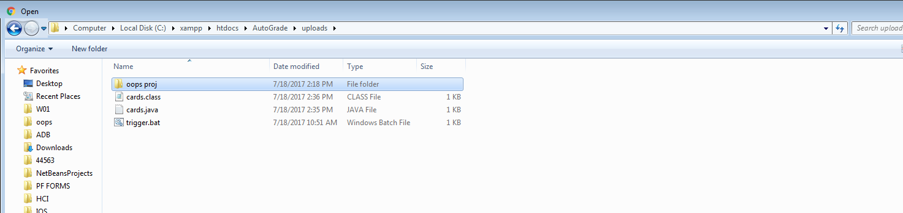

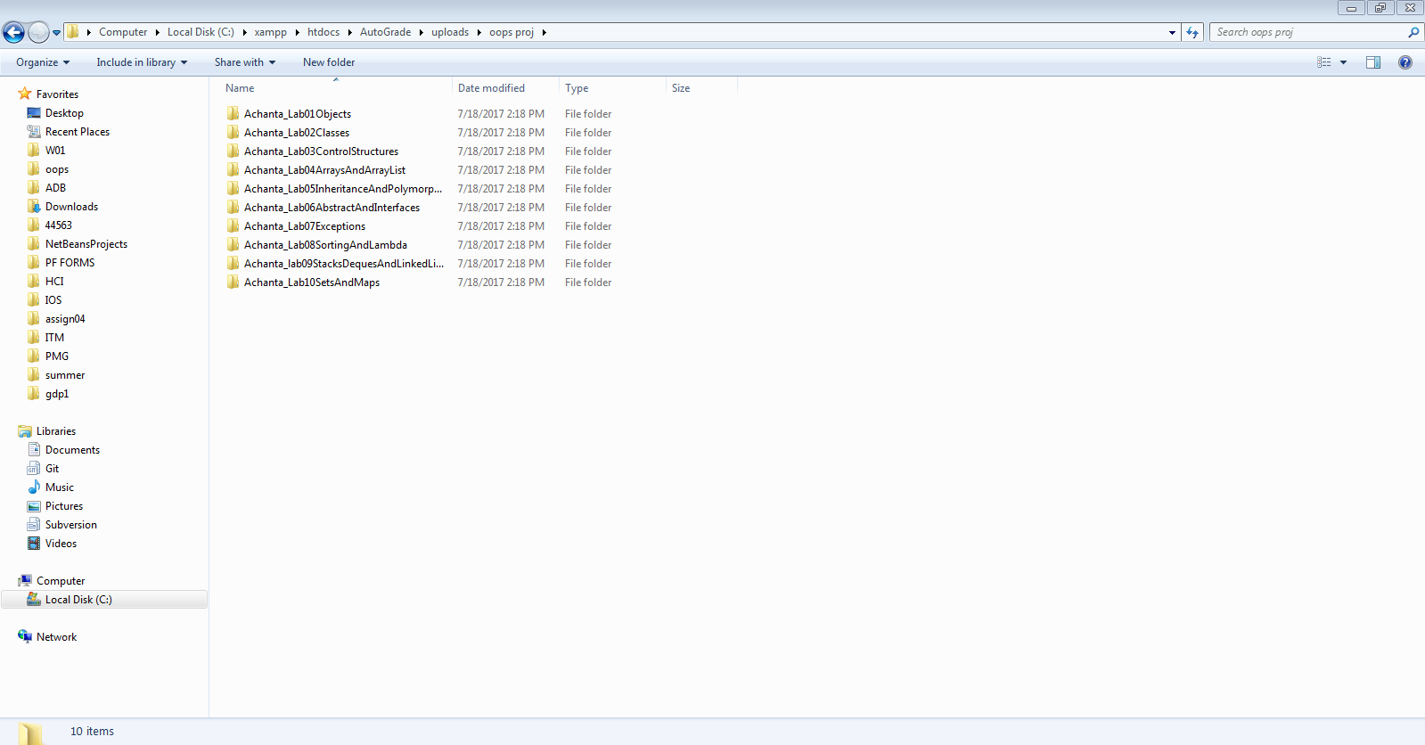

Fig: e

This page shows that cards.java file is being selected to upload.

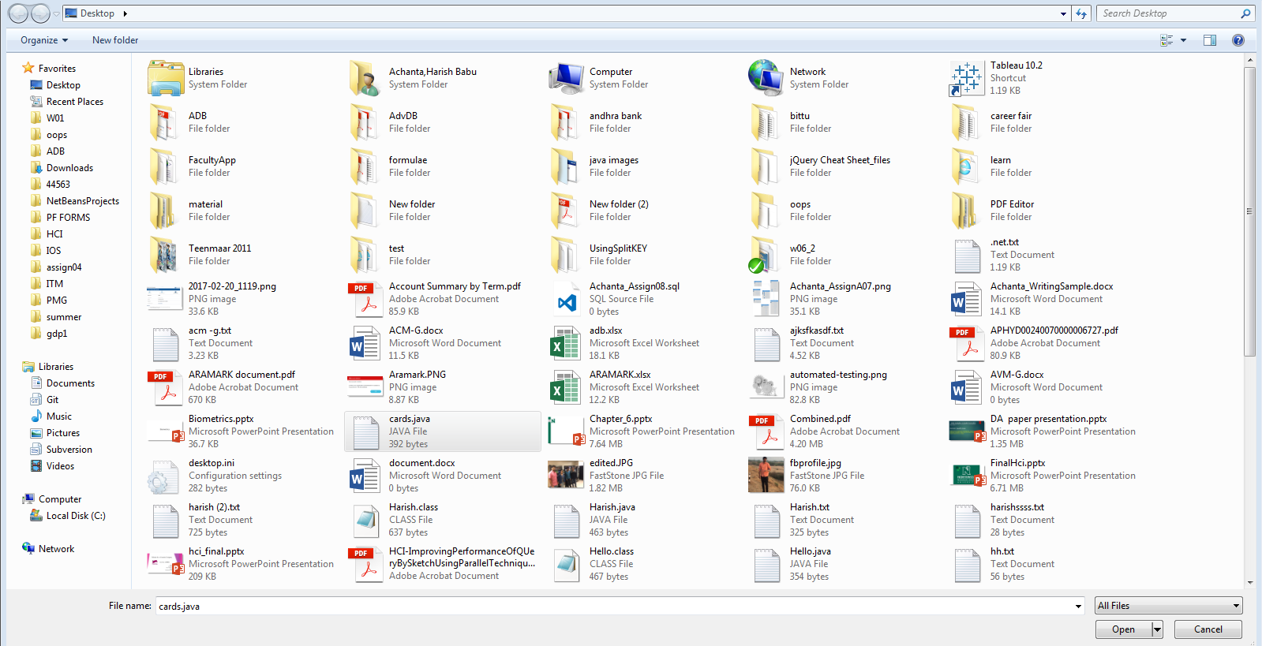

Fig: f

This page shows that “cards.java” file is uploaded.

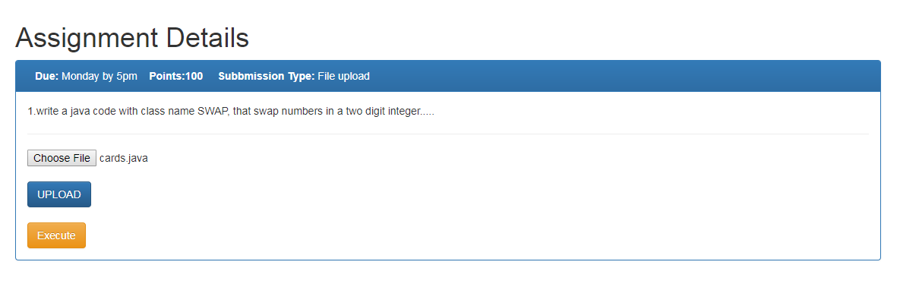

Fig: g

This page shows that location of .java file.

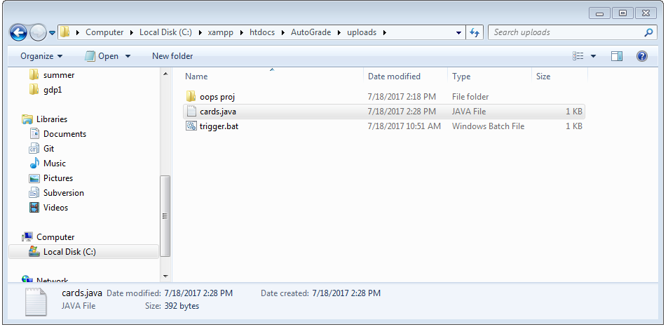

Fig: h

This image shows “trigger.bat”.This file is used to execute the cards.java file

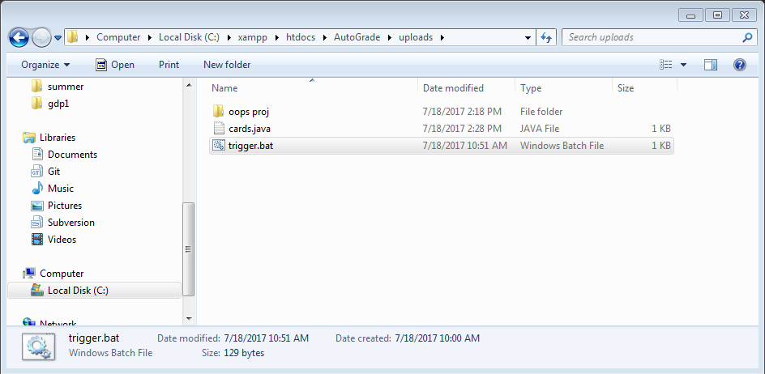

Fig: i

This images shows that .class file. The file is executed and .class file is created which implies that .java file is successfully compiled.

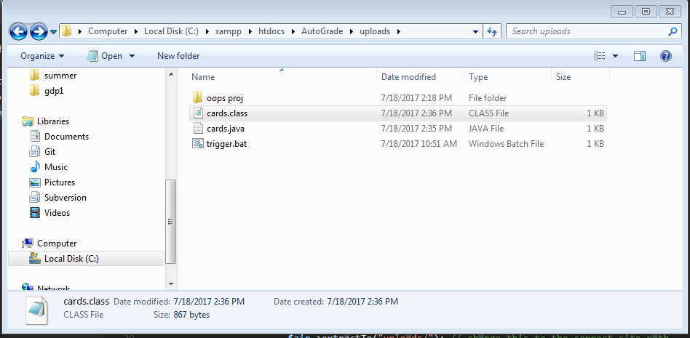

Fig: j